# SRS (Continued)

3.4 Design Constraints

* Contraints imposed by other standards, hardware limitations, etc.
  1. Duality Characteristics
* A total of 11 criteria, e.g. correctness, efficiency, flexibility, integrity, interoperability, maintainability, ...
  1. Other requirements
     1. Databases: Requirement for any database that is to be developed as part of the product. These might be
* Types of information
* Frequency of use
* Accessing capabilities
* Data element and file description
* Relationship of data elements, records, and files
* Static and dynamic organization
* Retention requirements for data
  + 1. Operation: Normal and special operations required for each user, eg.
* Various modes of operation in the user organization, e.g. user initiated operation.
* Periods of interactive operation and periods of unattended operation
* Data processing support functions
* Backup and recovery operations
  + 1. Site adaptation requirement

1. Define the requirements for any data or initialization sequences that are specific to a given site, mission or operational mode (eg. Safety limits)
2. Specify the features that should be modified to the software to an installation

# SECTION 4

1. Definition acronyms and abbreviations
2. References
3. Appendices

4.3 appendices

1. Sample I/O formats, description of cost analysis studies, results of user surveys
2. Supporting and background information that can help the readers of the srs
3. A description of the problems to be solved by the software
4. The history, background, experience and operational characteristics of the organization supported
5. A cross reference list, arranged by milestone of those incomplete software requirements to be completed by specific milestones
6. Special packaging instruction for the code and the media to meet security, export, initial loading, or other requirements

4.4. Index

|  |
| --- |
| FORMAT-I (All functional requirements specified first)  ----  ----  ----   1. Specific Requirement    1. Functional requirements       1. Functional requirement 1          1. Introduction          2. Inputs          3. Outputs       2. Functional Requirement 2   ---  ---   * 1. External Interface requirements      1. User Interfaces      2. Hardware interfaces      3. Software interfaces      4. Communication Interfaces   2. Performance requirements   3. Design Constraints      1. Standard compliance      2. Hardware limitations   4. Quality Characteristics      1. Correctness      2. Efficiency   5. Other requirements      1. Database      2. Operations      3. Site Adaptation   ---  --- |
| FORMAT 2 (Each Interface Requirement Applied to each functional Requirement first)   1. Specific requirements    1. Functional Requirements       1. Functional requirement 1          1. Specification             1. Introduction             2. Inputs             3. Processing             4. Output          2. External Interfaces             1. User interfaces             2. Hardware Interfaces             3. Software Interfaces             4. Communication Interface       2. Functional Requirement 2       3. Functional Requirement 3       4. …       5. ..       6. (3.1.n) Function Requirement n    2. Performance requirements    3. Design Constraints    4. Duality Characteristics       1. ---    5. Other requirements       1. Database       2. Operations       3. Site adaptation |
| FORMAT – 3 (A Functional Requirement, the rest of the requirements and all interface requirements)   1. Specific requirements    1. Functional Requrements       1. Functional Requirement 1          1. Introduction          2. Inputs          3. Processing          4. Output          5. Performance requirements          6. Design constraints             1. Standard Compliance             2. Hardware limitations             3. ---             4. ---          7. Attributes             1. Security             2. Maintainability          8. Other requirements             1. Database             2. Operations             3. Site adaptation       2. Functional Requirement 2   ----  ----   * 1. External Interface requirements      1. User interfaces         1. Performance requirements         2. Design constraints            1. Standard Compliance            2. Hardware limitation         3. Duality Characteristics            1. ----         4. Other requirements            1. Database            2. Operations            3. Site adaptation      2. Hardware Interfaces      3. Software interfaces      4. Communication interfaces |

5. Software Estimation

FP Based estimation: The function point metric (FP) Can be used effectively as a means of measuring the functionality delivered by a system

Measures of Information Domain

1. Number of External inputs (EIs)
2. Number of External Outputs (EOs)
3. Number of External inquiries (EQs)
4. Number of internal logical files (ILFs)
5. Number of external interface files (EIFs)

Step 1

|  |  |  |  |  |  |
| --- | --- | --- | --- | --- | --- |
| Information Domain value: | Count | Simple | Average | Complex |  |
| EIs | □ | 3 | 4 | 6 | □ |
| EOs | □ | 4 | 5 | 7 | □ |
| EQs | □ | 3 | 4 | 6 | □ |
| ILFs | □ | 7 | 10 | 15 | □ |
| EIFs | □ | 5 | 7 | 10 | □ |
| Count Total(Raw Functional Point Count) |  |  |  |  | □ |

$$FP=\left(Rawfunctionpointcount\right)×\left[0.65+0.01∑\left(F_{i}\right)\right]$$

The Fi (I = 1 to 14) are VALUE ADJUSTMENT FACTORS

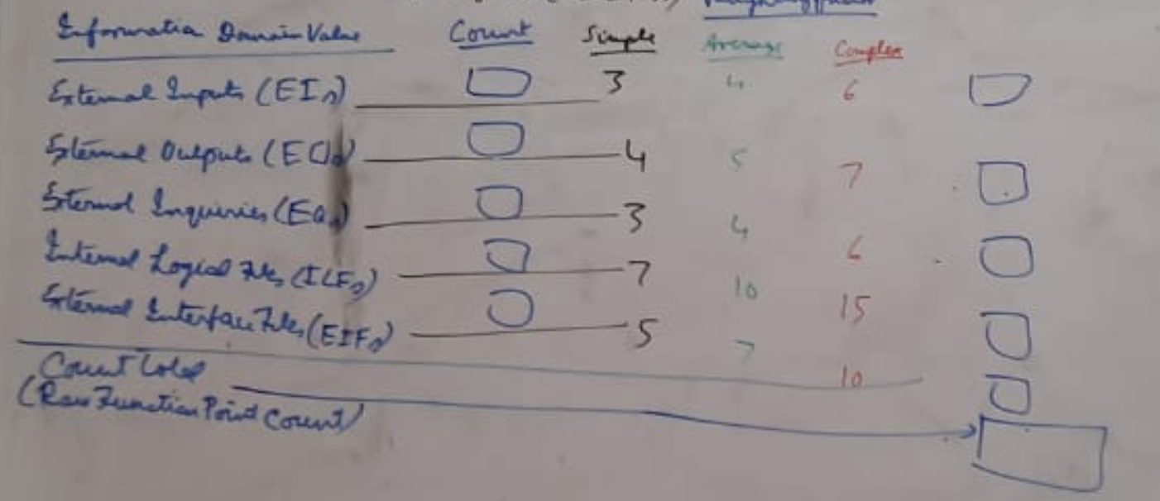

Step 2: Apply value adjustment factors

Adjust the raw function point count to account for environmental factors that affect the entire software development process

1. Factor has no effect on the product
2. Effect of the factor is minor
3. Factor has a moderate effect
4. Factor has average effect
5. Effect of the factor is significant and the software design will be influenced by this factor
6. Factor is essential

The factor ratings (for the 14 environmental factor) are summed to calculate total environmental influence factor (N)

Step 3: Calculate the complexity adjustment factor (CAF)

$$CAF=0.65+\left(0.01×N\right)$$

|  |  |  |  |  |
| --- | --- | --- | --- | --- |
| Example | Simple | Average | Complex | Function points |
| External Outputs | 12 x 4 = 48 | 11 x 5 = 55 | 5 x 7 = 35 | 48+55+35 = 138 |
| External Inputs | 8 x 3 = 24 | 9 x 4 = 36 | 6 x 6 = 36 | 24 + 36 + 36 = 96 |
| --- |  |  |  |  |
| --- |  |  |  |  |
| Raw Function Point Count | | | | 652 |

Suppose N = 51

Step 3: CAF = 0.65 + (0.01 x N) = 1.16

Step 4: The adjusted Functional Points

AFP = FPraw X CAF = 652 x 1.16 = 756.32

VALUE ADJUSTMENT FACTORS

The Fi (i – 1 to 14) are based on responses to the following question:

1. Does the system require reliable backup and recovery? (4)
2. Are specialized data communication required to transfer information to or from the application? (2)
3. Are these distributed processing functions? (0)
4. Is performance critical? (4)
5. With the system run in an existing heavily utilized operational environment? (3)
6. Does the system require online data entry? (4)
7. Does the online data entry require the input transaction to be built over multiple screens or operations? (5)
8. Are the ILFs updated online? (3)
9. Are the inputs, outputs files or inquiries complex? (5)
10. Is the internal processing complex? (5)
11. Is the code designs to be reusable? (4)
12. Are conversion and installation included in the design? (3)
13. Is the system designed for multiple installations in different organization? (5)
14. Is the application designed to facilitate change and for ease of use by the user? (4)

--------- Sum = 51